**How to use the notebook**

Install python and dependencies

Windows:

* Install the latest stable release of Python 3.x as per the instructions here <https://www.howtogeek.com/197947/how-to-install-python-on-windows/>
* Install pip by following these instructions: <https://www.liquidweb.com/kb/install-pip-windows/>
* Install the dependencies of the notebook by pasting this block of code into the command window (doesn’t matter what directory you are in):

pip install pandas==1.0.3

pip install xlrd==1.2.0

pip install numpy==1.18.1

pip install matplotlib==2.2.2

pip install scipy==1.1.0

pip install jupyterlab

pip install notebook

Create a folder structure

* 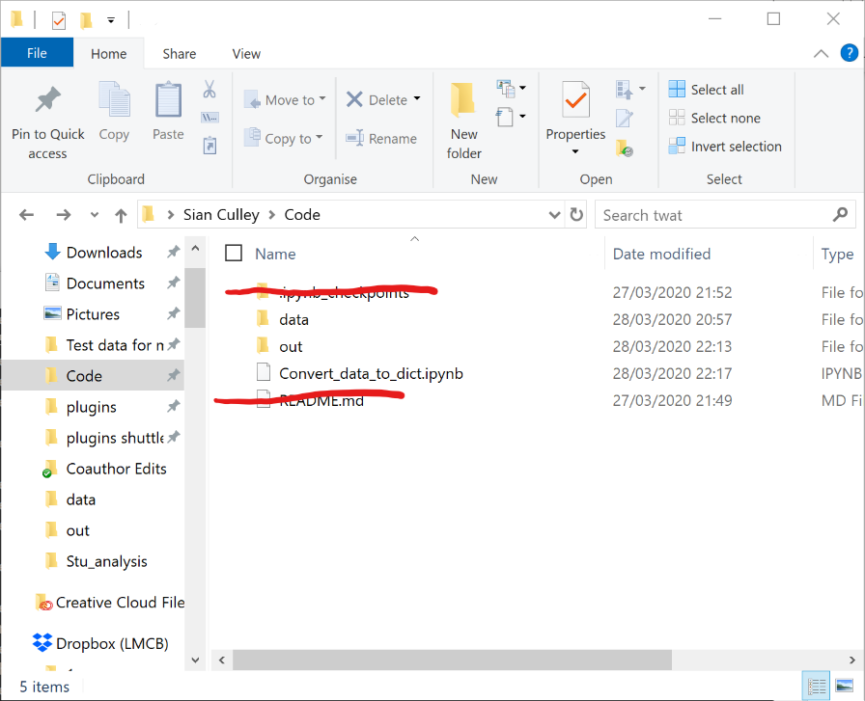Create a ‘Code’ folder that is somewhere straightforward to navigate to from the command line
* Inside here, create a ‘data’ folder – this is where you will put your excel spreadsheets
* Also create an empty folder called ‘out’ – this will contain files that are created by my code (.csv files with fit parameters and png files of plots)
* Finally, put the ‘Convert_data_to_dict.ipynb’ file into the Code folder

Run the notebook

* Open the command line and navigate to your code folder. Then type jupyter notebook

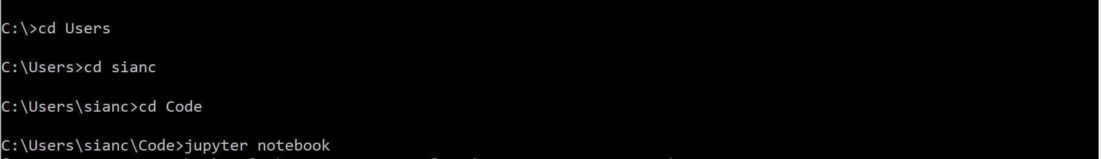

Your browser should open with a page mirroring your Code folder.

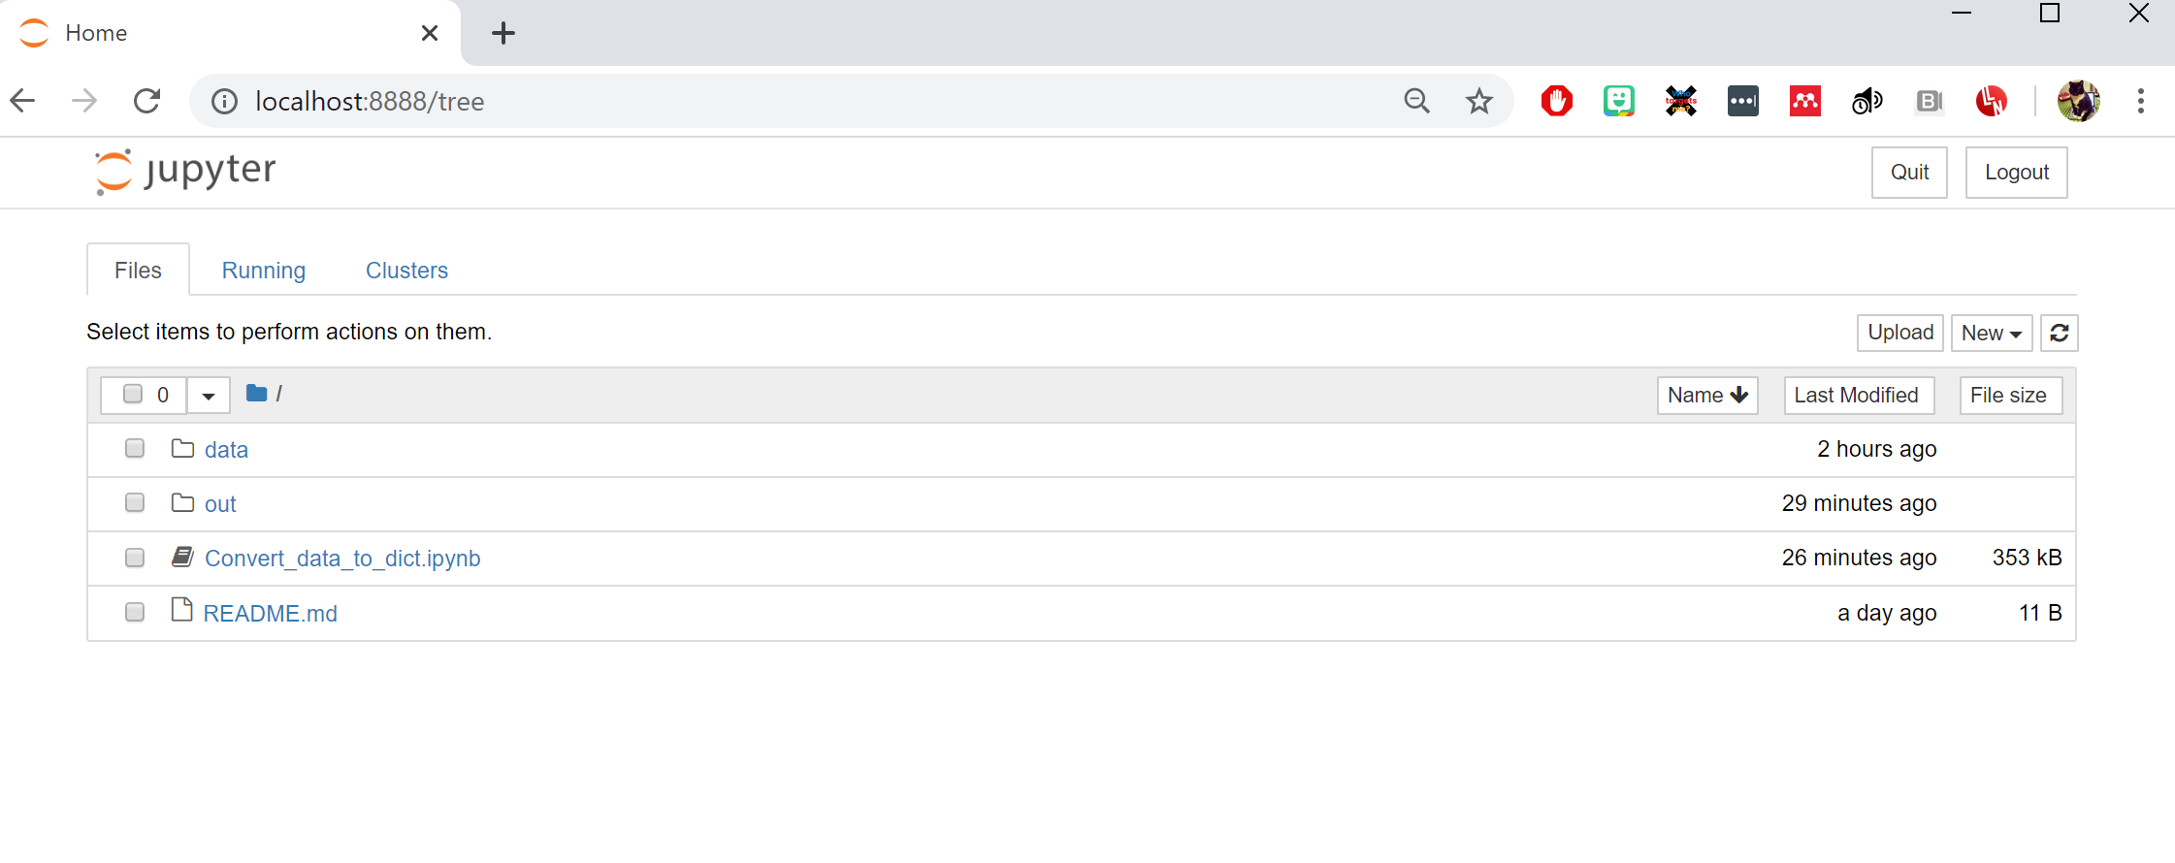

* Click on Convert_data_to_dict.ipynb – this will open the notebook in a new brower tab
* Click ‘Kernel’ -> ‘Restart and clear all outputs’ and say yes to the warning that appears